Guided Lab - 303.1.2B

How to Run Java Programs in IntelliJ Ultimate

# Introduction:

In this lab, we will demonstrate how to run Java programs using IntelliJ Ultimate.

# Lab Objective:

By the end of this lab, learners should be able to run a Java program using IntelliJ Ultimate.

# 

# Instructions

For this lab, you must have IntelliJ Ultimate pre-installed on your computer. **Download IntelliJ here** [**IntelliJ download**](https://www.jetbrains.com/idea/download/other.html)**.**

# 

### 1. Open IntelliJ Ultimate and click on New project.

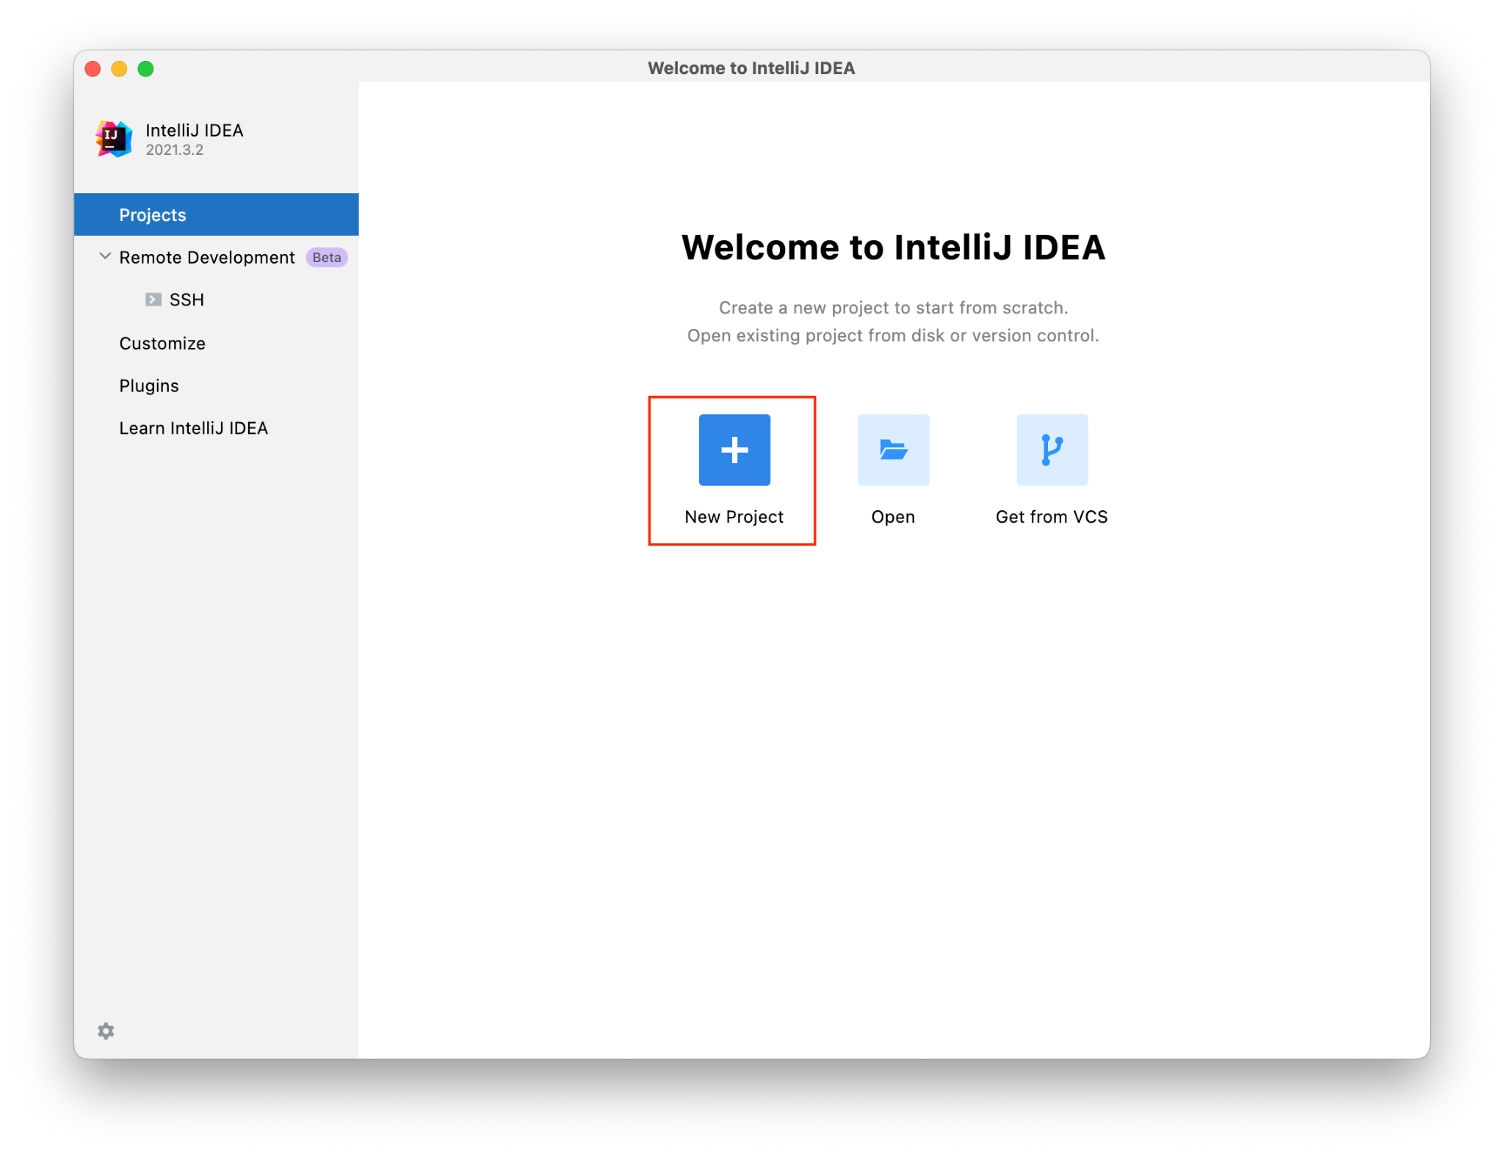

### 

### 2. Go to the JDK section and click on the dropdown bar. Next click on Download JDK.

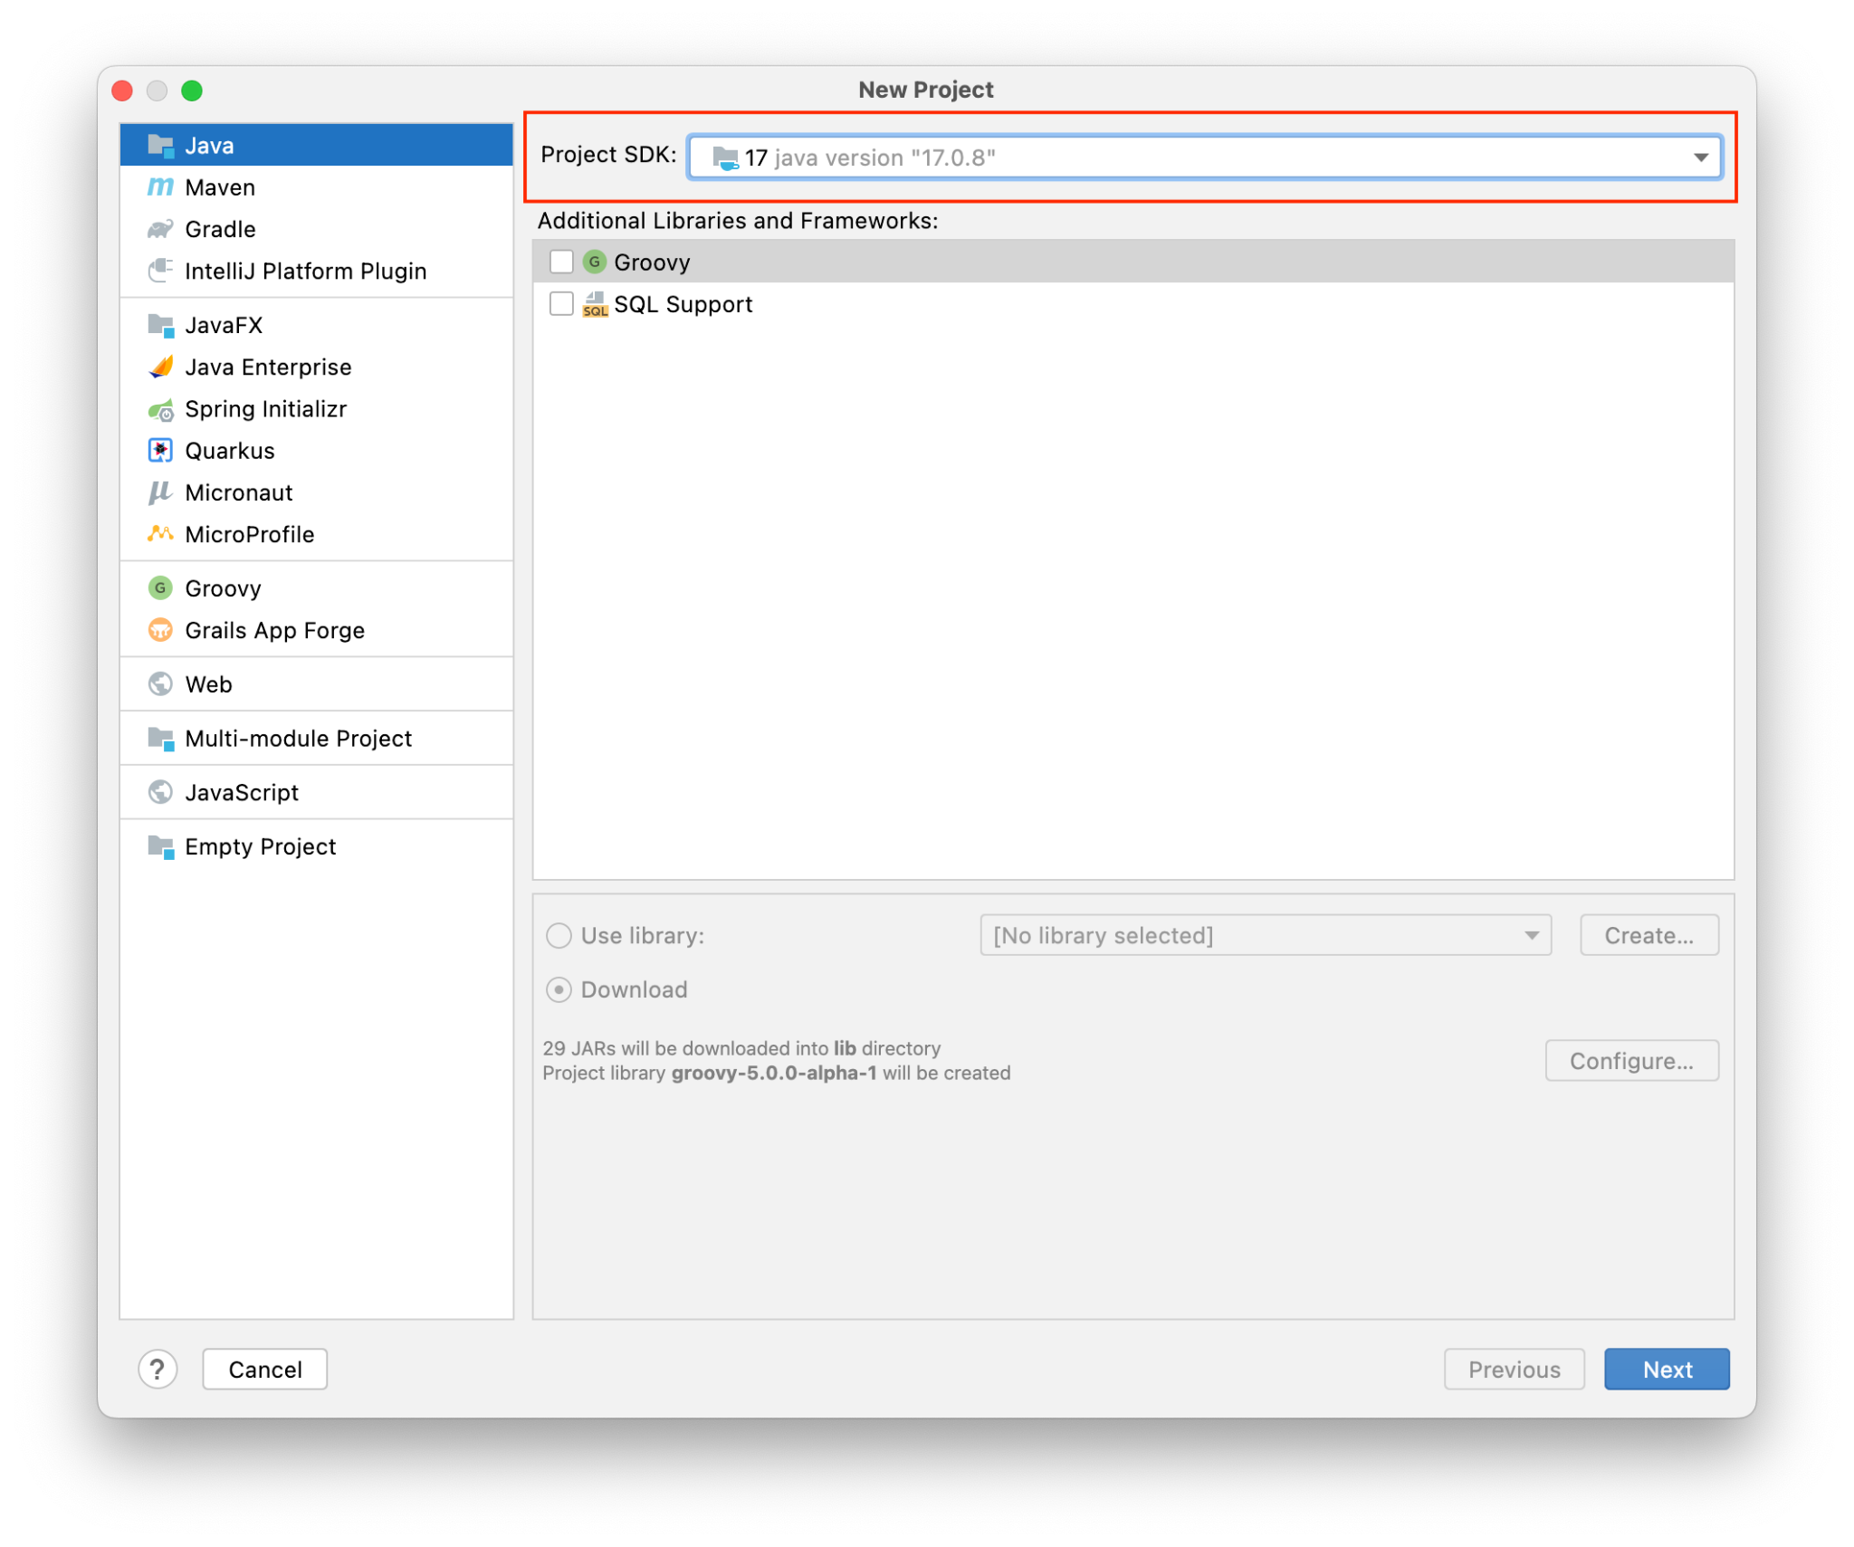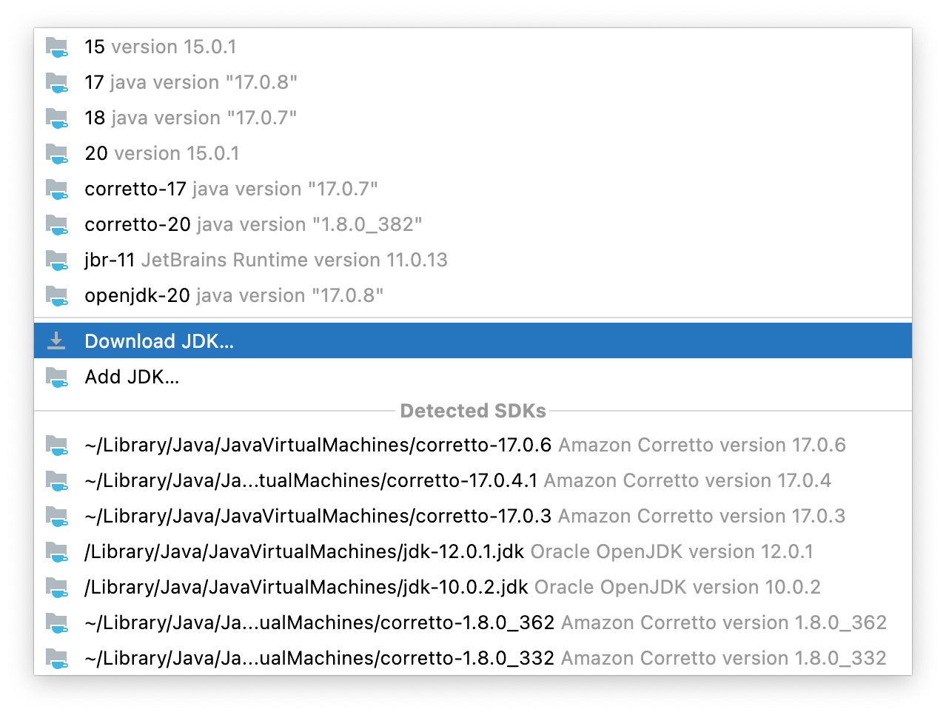

### 

### 3. Go to the vendor dropdown menu and click on Amazon Coretto. After downloading the appropriate version, click Next at the bottom right-hand corner.

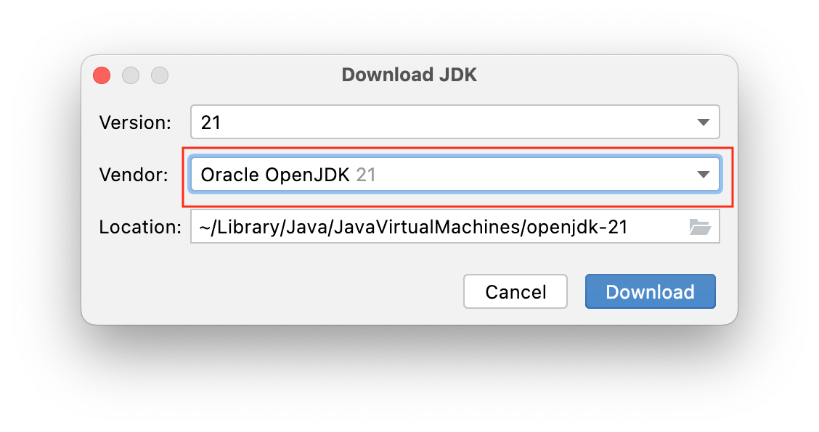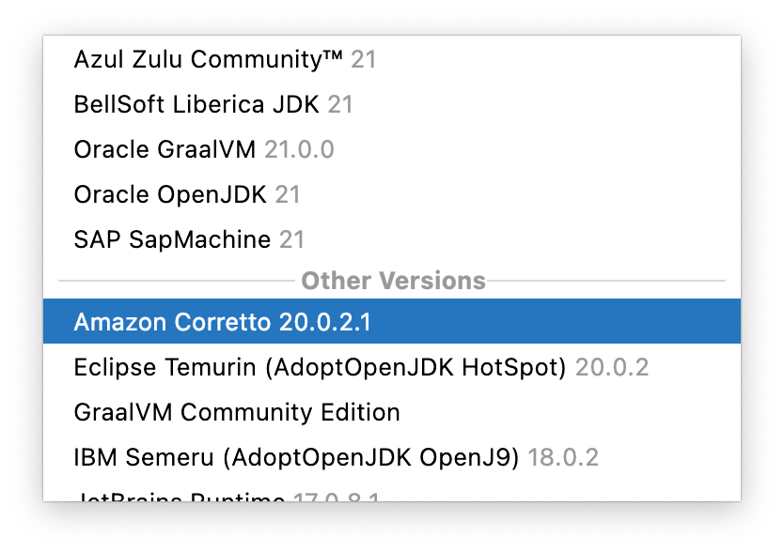

### 

### 

### 4. Click on the *(Create project from template)* checkbox.

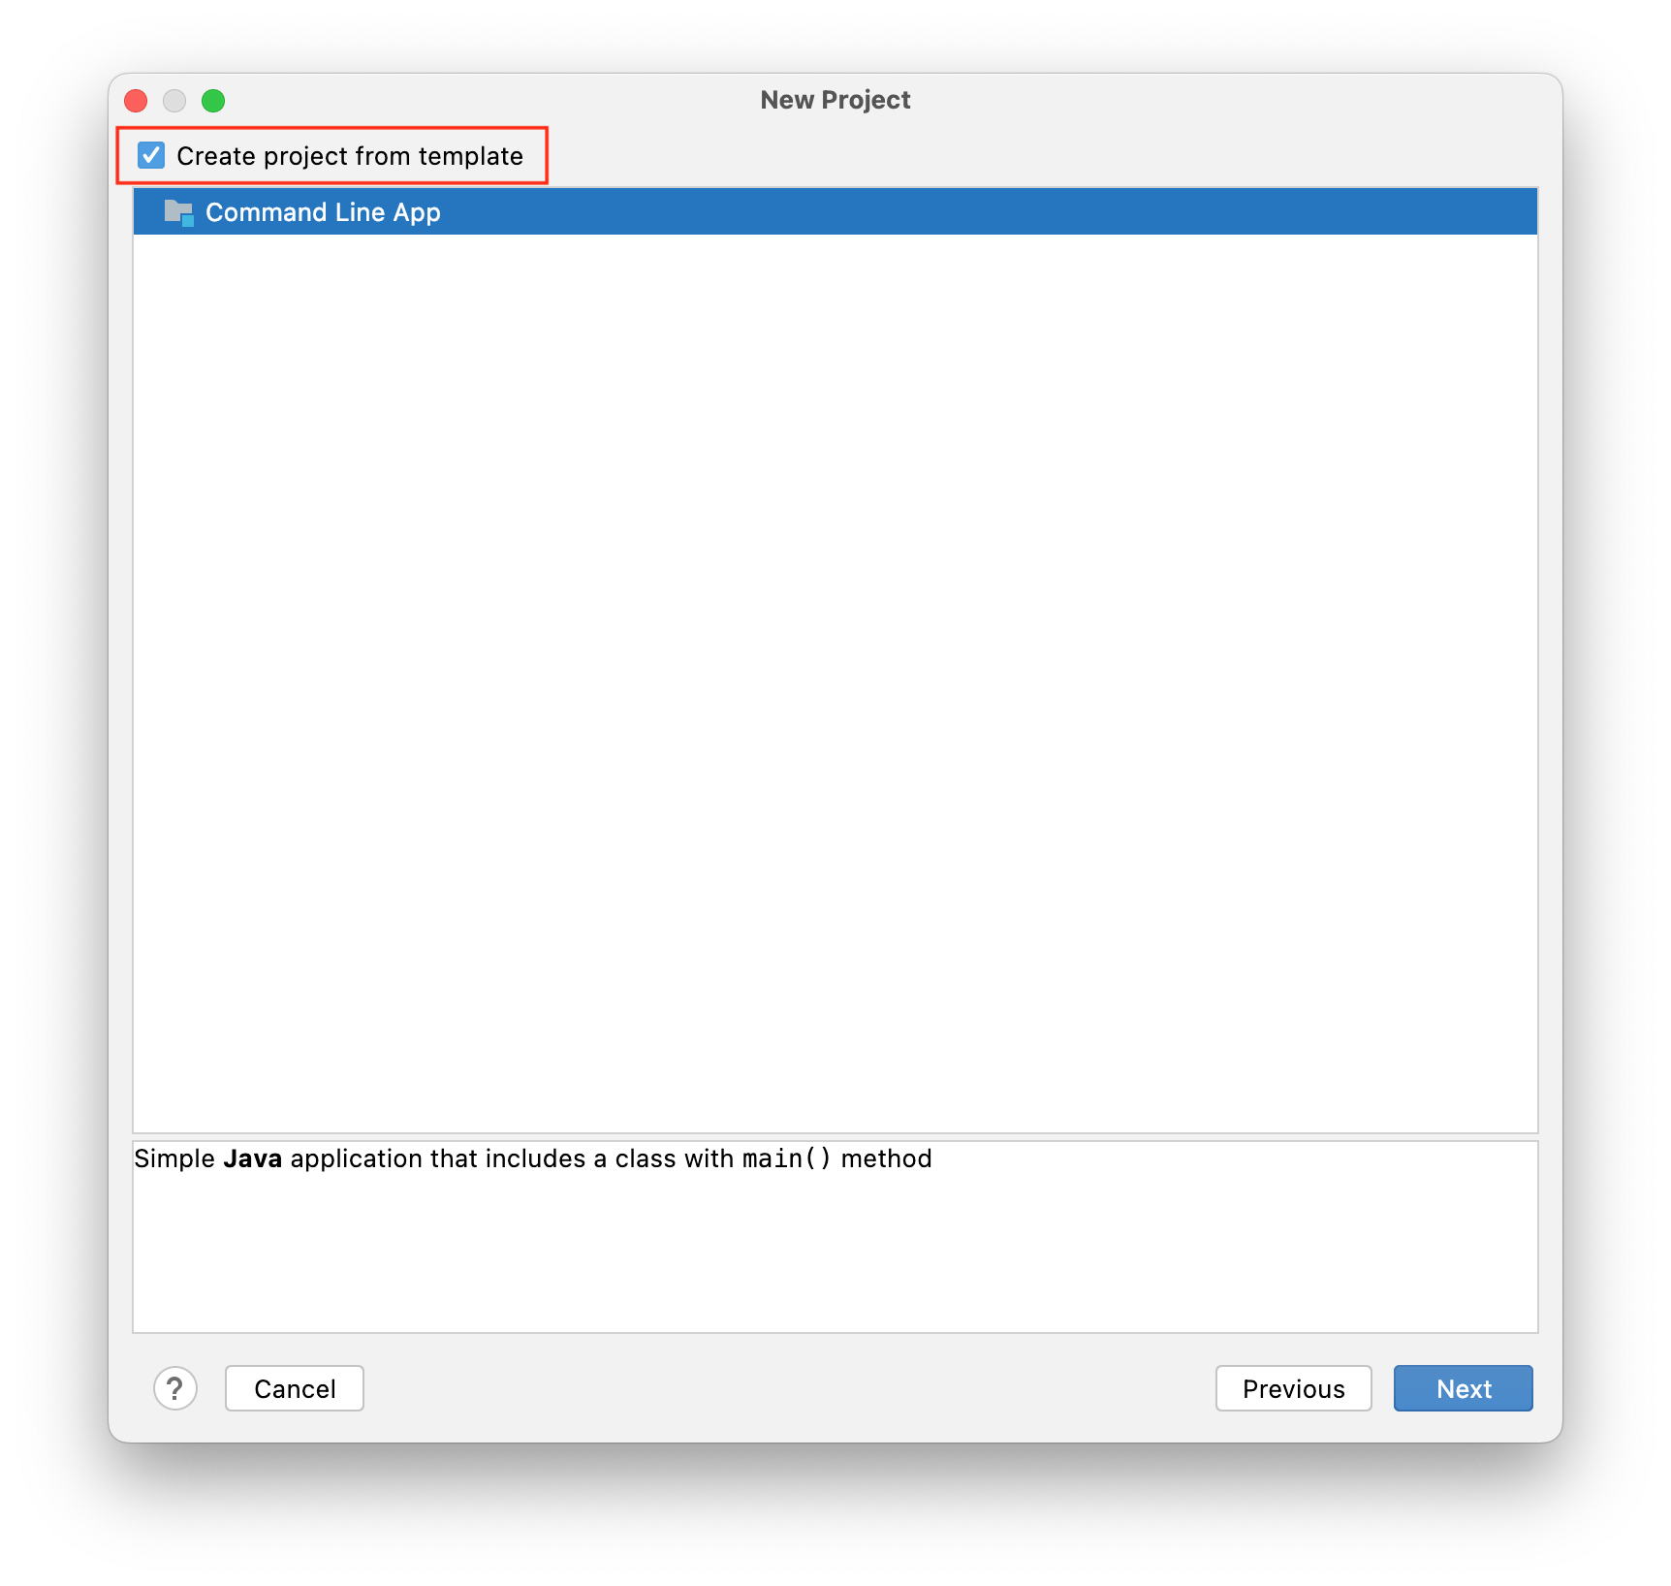

### 5. Name your new project.

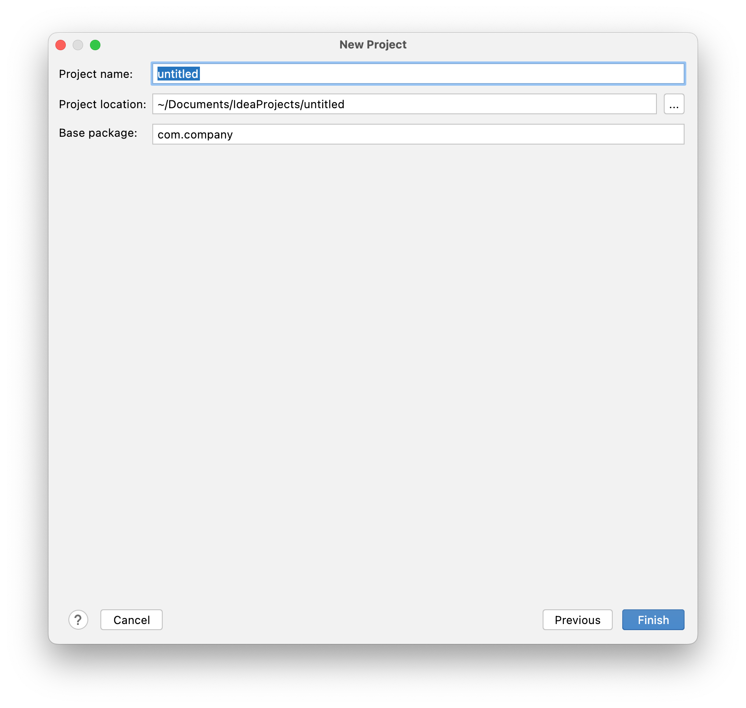

### 6. To run a program in IntelliJ, click on the green Play icon in the top-right or left corner, depending on your version and layout. You may see the Main or Current file depending on your version.



**7. Output**

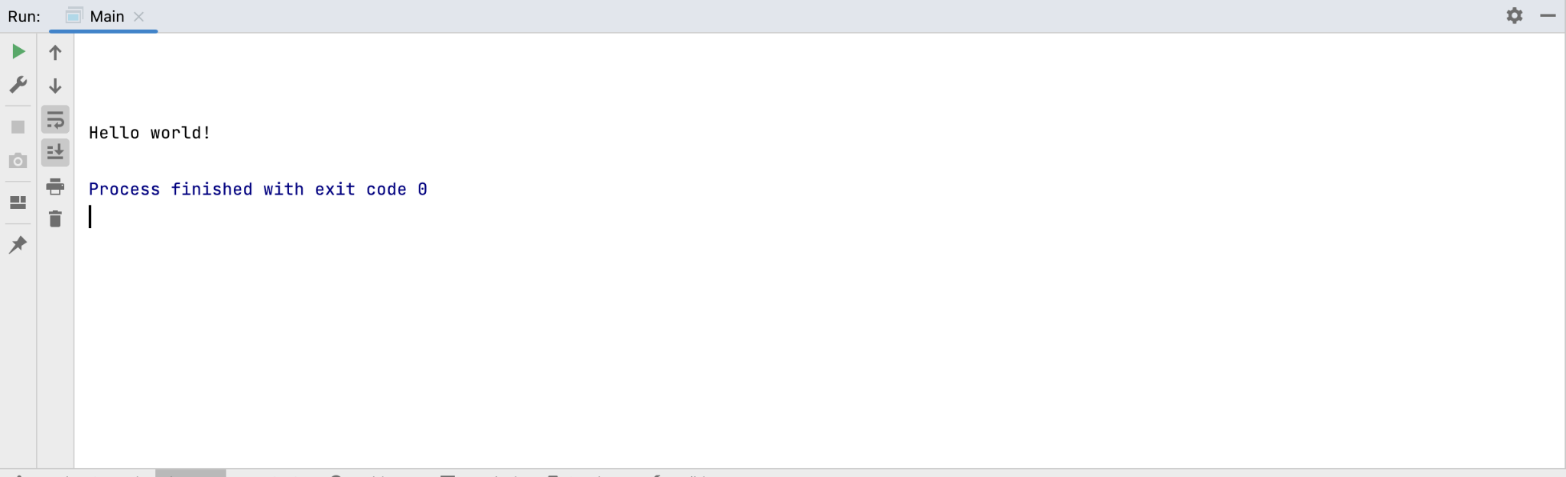

## Submission Instructions:

**Submission Instructions:**

Include the following deliverables in your submission -

* + Submit your screenshot using the Start Assignment button in the top right corner of the assignment page in Canvas.

**CANVAS STAFF USE ONLY: Canvas Submission Guideline:**

| **Instructions for Canvas Assignment Creation** |
| --- |
| **Assignment Name: GLAB - 303.1.2- How to Run Java Program in IntelliJ Ultimate**  **Points:** **100**  **Assignment Group: Module 303: Java SE Review (Not Graded)**  **Display Grade As: Complete/Incomplete**  **Do not count this assignment towards the final grade: Checked**  **Submission Types: File Uploads**  **Everything else is the default.** |

## 